1: Types of Printers, Scanners and Webcams

Device | Type | Real-Life Use Case
Printer | Inkjet Printer | Printing college assignments and color photos
 | Laser Printer | Printing many documents in an office
 | Thermal Printer | Printing bills and receipts at shops
Scanner | Flatbed Scanner | Scanning certificates and important documents
 | Sheet-fed Scanner | Scanning multiple pages quickly
Webcam | Built-in Webcam | Attending online classes or meetings
 | USB Webcam | Video calls and online interviews

2: Diagram – Connecting a Home Printer to a Computer
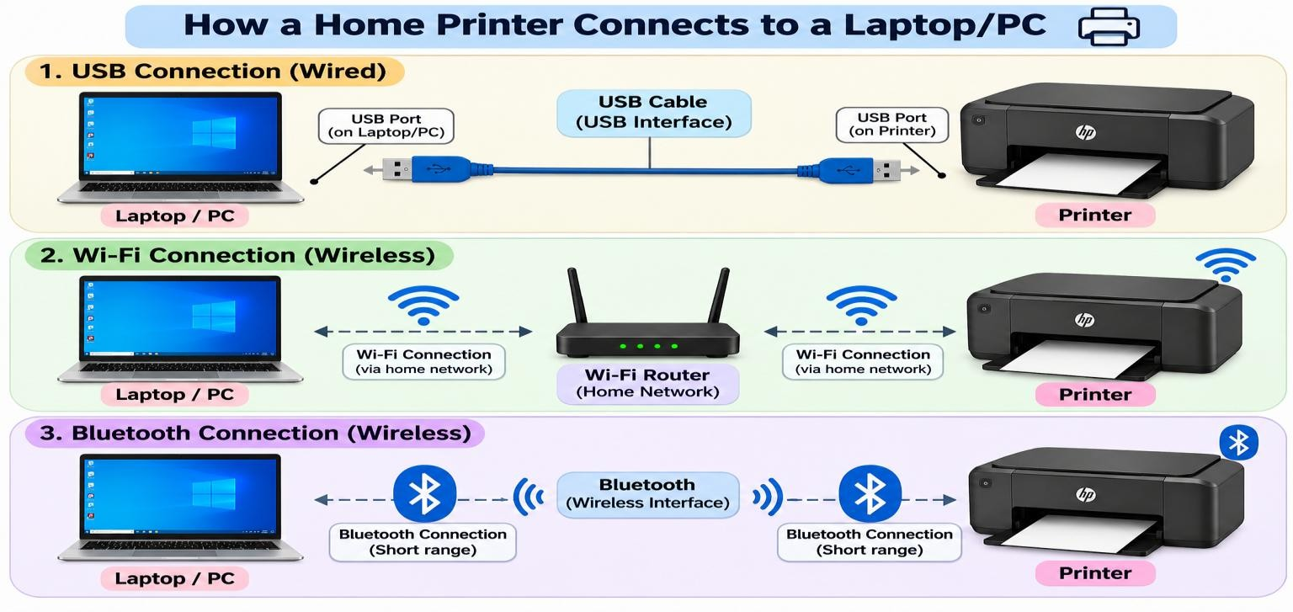

3: Connection Interfaces

Connection Interface | Advantage | Disadvantage
USB | Fast and reliable connection | Requires a cable
Wi-Fi | Wireless and can connect multiple devices | Requires Wi-Fi/network setup
Bluetooth | Easy wireless connection for nearby devices | Short range and usually slower than USB

4: Steps to Connect a Printer to a Computer Using Wi-Fi

Device: Printer
Connection Method: Wi-Fi (Wireless)

Steps:

- Turn on the printer and connect it to the power supply.
- Make sure the printer supports Wi-Fi.
- On the printer, open Wi-Fi or Network Settings.
- Select your home Wi-Fi network from the available networks.
- Enter the Wi-Fi password and connect the printer to the network.
- Connect your laptop or PC to the same Wi-Fi network.
- On the computer, open Settings → Bluetooth & devices → Printers & scanners.
- Click Add device and wait for the computer to find the printer.
- Select your printer from the list and click Add device.
- If required, install the printer driver or printer software.
- Open any document and select Print.
- Select the connected printer and click Print to check the connection.

